MINUTES OF THE MEETING OF ASHURST PARISH COUNCIL, HELD AT ASHURST VILLAGE HALL ON Monday 20th April 2026 AT 5.30PM.
Attendance:
Ashurst Parish Council (APC) | Cllr Fischel (Chair), Cllr Russell (Vice Chair), Cllr Knight, Cllr Bunce, Cllr Nicholson
Horsham District Council (HDC)
Clerk
Public | 0

The Chair welcomed everyone to the meeting.
- Apologies for Absence
Apologies were received from Cllr. Hammond
- Declarations of interest
Councillors were reminded to return any revised Declarations of Interest, as defined under the Localism Act 2011.

There were no Declarations of Interest on any agenda items in this meeting.

- Public forum and questions

There were no members of public questions.

- Approval of the Minutes of the Meeting of the Parish Council 5th March 2026
It was resolved to approve the minutes from the last meeting held on 5th March as a true and accurate record.
- Planning Applications
The pre- planning application below was considered:
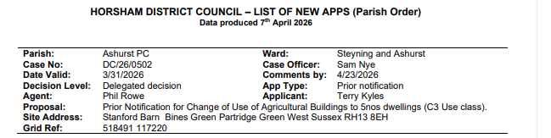
It was resolved to object to this Prior Notification proposal.
Given the scale, potential impact and lack of detail provided, the Council recommended that it should be submitted as a Full Planning Application.

This will enable all aspects of the proposal, including the impact of additional light, sewage services, access and additional volume of traffic and whether the existing structures are of sufficient quality to convert to 5 new dwellings, to be considered further.

- Correspondence

There was no correspondence.

The meeting ended at 6.00 pm.

