To: All Members

You are hereby summoned to attend the following meeting for the transaction of the business stated in the agenda below.

Full Council Meeting
to be held on Thursday 24th September 2026 at 7:30pm
at Ashurst Village Hall.

Members of the public and press are welcome to attend this meeting and may speak during the public adjournment at the discretion of the Chairman and in accordance with standing order 1 e-g. Questions relating to any other items that are not on this agenda should be referred to the Chair of the Council or Clerk as appropriate and outside this meeting.

The law allows the public proceedings of council meetings to be recorded, which includes filming as well as audio-recording. Photography is also permitted. By attending this meeting, you are consenting to be filmed. As a matter of courtesy, please advise the Clerk if you intend to record any part of the proceedings.

Oliver Last


Clerk to the Council
17 September 2026
AGENDA
- Apologies for Absence
To receive apologies for absence
- Declarations of interest
To receive any declarations of interest as defined under the Localism Act 2011.
- Public forum and questions
Public forum and questions Members of the public are reminded that only questions and statements relating to items on this agenda will be allowed. Public participation shall not exceed 15 minutes and a member of the public shall not speak for more than three minutes. During discussions of sensitive or confidential matters, the public will still be excluded.

- Approval of the Minutes of the Meeting of the Parish Council 16th July 2026

- District Councillor Reports
To receive an update report.

- Conservation and Biodiversity Initiatives
To receive an update on Biodiversity and Climate Change initiatives.

- HALC/Devolution and Local Government Reorganisation
To receive any updates and consider any actions to be taken and to receive a report regarding HDC’s governance review.

- Planning Applications
Review any planning applications received since the publication of the agenda
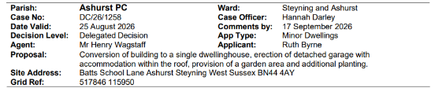
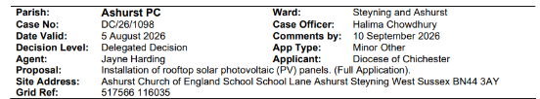

- Planning Decisions from HDC
To receive and review the decisions on planning applications from Horsham District Council.

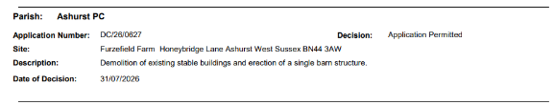
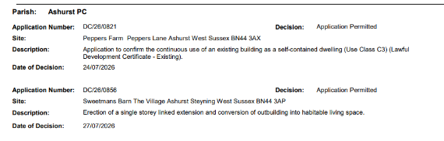
Compliance Complaints
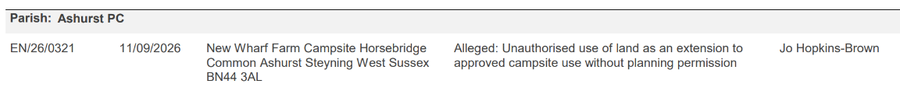
- Payments and bank reconciliation*
- To review the schedule of payments and bank reconciliation since the last meeting (July 16th)* Appendix 1
- To review the Q2 budget position.

- Recreation Ground
- To receive a report on the Recreation Ground Trust’s income and expenditure since the last meeting (July 16th).* Appendix 2
- To receive an update on the rebuild/replacement of the John Eaton Hut.
- To receive a general update on the Recreation Ground.
- To discuss the possible further protection of the Recreation Ground.

- Speedwatch and Speed Restrictions within the Parish
To receive an update on any recent developments.

- Operation Watershed
To receive an update regarding our Operation Watershed application.

- Government email addresses and website
To discuss how to implement the new email addresses. Information to be provided by Cllr Bunce.

- Local Government Pay Settlement
To receive an update from the Clerk and agree the pay settlement.

- Correspondence

- Forthcoming Dates

