MINUTES OF THE MEETING OF ASHURST PARISH COUNCIL, HELD AT ASHURST VILLAGE HALL ON 16TH JULY 2026 AT 7:30PM.
Attendance:
Ashurst Parish Council (APC) | Cllr Fischel (Chair), Cllr Russell (Vice Chair), Cllr Knight, Cllr Bunce, Cllr Nicholson
Horsham District Council (HDC) | Victoria Finnegan and Nicholas Marks ​​​​
Clerk | Oliver Last
Public | 0

The Chair welcomed everyone to the meeting at 19:53
- Apologies for Absence
There were no apologies received.
- Declarations of interest

Councillors were reminded to return any revised Declarations of Interest, as defined under the Localism Act 2011.
There were no Declarations of Interest on any agenda items in this meeting.

- Public forum and questions
There were no members of public questions.
- Approval of the Minutes of the Meeting of the Parish Council 28th May 2026
The minutes of the Full Council Meeting of 28th May 2026 were approved as a true and accurate record.
- District Councillor Reports

Councillor Finnegan updated the council, informing them that the Government has again delayed its decision on the future structure of councils in West Sussex, with no outcome now expected before October 2026. All eight existing councils will continue delivering services as normal, and residents should keep contacting them in the usual way. Despite the delay, the Government still intends to create a new shadow authority in May 2027, with the new council taking over in April 2028. Work has also begun on the wider Sussex & Brighton strategic authority ahead of the future mayoral model planned for 2028.
Horsham District Council has completed the first stage of its Governance Review. Ashurst was identified as a clear “no change” parish, with all respondents supporting the current boundary, name and number of councillors. A second consultation will run until 24 August to confirm these findings.

The Horsham Local Plan continues through examination. The independent inspector has required additional housing sites and policy changes before the plan can be adopted. As a result, two consultations are taking place this summer: the Main Modifications to the 2023–2040 plan, and the early “Horsham District 2045” scoping consultation, which asks residents what priorities the next plan should address. A separate “call for sites” is also open for anyone wishing to suggest land for future uses.

County‑wide climate work is progressing, with a consultation due in August on mitigation and adaptation measures. Transport remains the largest contributor to emissions in West Sussex, and fuel poverty affects around 9% of households. Local examples of climate resilience include floodplain restoration work in Adur.

West Sussex County Council is awaiting its next Ofsted inspection, expected no earlier than September. Recent local achievements include HDC’s White Ribbon accreditation, Horsham Park receiving a Green Flag award, and continued refurbishment works at The Capitol. £7.2 million of Community Infrastructure Levy funding has been allocated to district projects, with £2.75 million remaining.

Saxon Weald is progressing long‑delayed works at 1 and 4 School Lane, Ashurst, with contractors expected to be appointed shortly. Regarding Bines Green, the Class Q permitted development decision was made within the limited scope of national legislation; the Stage 2 complaint has not been upheld, though any concerns about works exceeding approval can be raised with the council’s compliance team.

- Conservation and Biodiversity Initiatives

Councillor Knight reported that several ancient trees, each with a girth of 3.5 metres, have been formally added to the national directory. Residents, farmers, and landowners are being encouraged to adopt environmentally supportive practices aligned with the Weald to Waves initiative, to which both the Recreation Ground and the churchyard have signed-up. Additional measures are being implemented to establish environmentally rich border areas around these sites. Engagement with the school continues, with pupils actively participating in activities designed to enhance their understanding of the local natural environment. There will be further detail to be brought to a future meeting.

It was resolved to acknowledge the update.
- HALC/Devolution and Local Government Reorganisation

Cllr Russell reported on the recent HALC meeting. The inspector has indicated a requirement for at least 21,000 homes within the area, with Buckbarn, Adversane, and an additional location currently under consideration as potential sites.

The governance review and associated asset transfers were also discussed. No significant changes are proposed within the governance review, and Ashurst has no assets identified for transfer at this stage.

It was resolved to acknowledge the update.

- Planning Applications

Review any planning applications received since the publication of the agenda
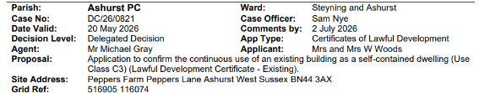

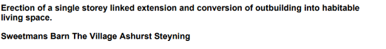
It was resolved to acknowledge the applications.
- Planning Decisions from HDC
The planning decisions were discussed.

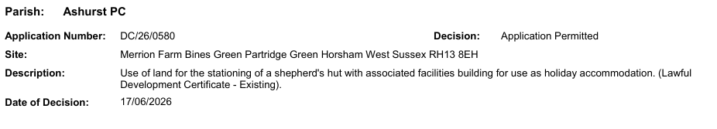
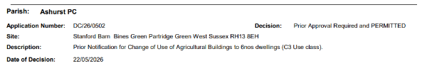

It was resolved to acknowledge the applications.

- Consider the Parish Council Grant applications

To discuss the grant applications
- Defib in the village - Already agreed £125
- Supporting Citizens Advice in West Sussex
- Air Ambulance Kent Surrey & Sussex
It was resolved to agree to support the Defib in the village and the Air Ambulance for £125.

- Payments and bank reconciliation*
The Clerk provided an update on the Council’s payments and bank reconciliation, confirming that all income and expenditure for the period had been reviewed and recorded accurately and that the bank reconciliation had been completed with no discrepancies identified. Current balances were verified against bank statements.

It was resolved to approve the schedule of payments since the last meeting (see Appendix 1) and the bank reconciliation of 16th July 2026.

- Recreation Ground
- The Clerk provided an update on the Council’s payments and bank reconciliation, confirming that all income and expenditure for the period had been reviewed and recorded accurately and that the bank reconciliation had been completed with no discrepancies identified. Current balances were verified against bank statements.

It was resolved to approve the schedule of payments since the last meeting (see Appendix 2) and the bank reconciliation of 16th July 2026.

- The Council discussed the rebuild or replacement of the John Eaton Hut and the Cricket Pavilion and the involvement of the residents of Ashurst.

It was resolved to wait and see whether any residents express any interest in joining a working group. The Chair will post a notice to this effect on the Village WhatsApp group. The Council will also host a ‘smartening up the Pavilion morning’ prior to the Dog Show on 6th September.

- The Chair advised that she is awaiting the arborist’s report on the oak tree, which has now died. Councillors considered the need to remove any dangerous branches and how much of the remaining trunk should remain. This could be turned into a carved feature, subject to arboricultural advice.
The Clerk explained that the playground inspections have been completed, with the annual inspection booked.
The legionella test results were received and had come back clear. The water temperature and compliance records are being completed by Cllr Russell. The results will be collated into a central folder.

It was resolved to acknowledge the update.

- Speedwatch and Speed Restrictions within the Parish

A meeting with the Police Speedwatch Coordinator is expected shortly. Several potential sites have been identified and will be assessed at the meeting.

It was resolved to acknowledge the update.

- Operation Watershed

The Council received an update on the ongoing drainage issues and water accumulation in Peppers Lane. It was noted that one potential solution under consideration was raising the road to improve water runoff. Three quotes for the proposed works are currently awaited, and upon receipt they will be reviewed to determine their suitability for an application to Operation Watershed. A recommendation will be brought to a future meeting for consideration.
It was resolved to acknowledge the update.
- Government email addresses and website

Cllr Bunce informed the council that he will prepare guidance for councillors on the new government email addresses and bring this to the next meeting. It was noted that the website continues to improve, with refreshed content and updated links.

It was resolved to acknowledge the update.

- Correspondence

There was no correspondence.

- Forthcoming Dates
24th September at 7.30pm with the Recreation Ground AGM to be held at 6.30.

There being no further business the meeting ended at 20:32.

