MINUTES OF THE MEETING OF ASHURST PARISH COUNCIL, HELD AT ASHURST VILLAGE HALL ON 24th September 2026 AT 7:30PM.
Attendance:
Ashurst Parish Council (APC) | Cllr Fischel (Chair), Cllr Russell (Vice Chair), Cllr Knight, Cllr Bunce, Cllr Nicholson
Horsham District Council (HDC) | Victoria Finnegan and Nicholas Marks ​​​​
Clerk | Oliver Last
Public | 0

The Chair welcomed everyone to the meeting.
- Apologies for Absence
There were no apologies received.
- Declarations of interest

Councillors were reminded to return any revised Declarations of Interest, as defined under the Localism Act 2011.
As a neighbour, Cllr Fischel declared that she would abstain from any discussions or decisions regarding the two planning items in Section 8 below. There were no other Declarations of Interest on any agenda items in this meeting.

- Public forum and questions
There were no members of public questions.
- Approval of the Minutes of the Meeting of the Parish Council 16th July 2026
The minutes of the Full Council Meeting of 16th July 2026 were approved as a true and accurate record.
- District Councillor Reports
Cllr Finnegan updated the councillors explaining that the Government has announced a pause to Local Government Reorganisation (LGR) affecting 14 areas, including West Sussex. The pause follows further legal review work and no timetable has yet been given for completion. As a result, Horsham District Council elections will now take place in May 2027, while elections to the Mayoral Combined Authority have been delayed until May 2028.
West Sussex County Council's Public Rights of Way email inbox will close on 2nd October, with residents encouraged to use the online reporting system instead. Support will remain available through the County Council Contact Centre. Following concerns raised about redundant roadwork signs at Clays Hill and Maudlin Lane, WSCC has apologised and confirmed that their removal is being progressed.
West Sussex Fire & Rescue Service continues to promote fire safety, particularly around lithium-ion batteries used in e-bikes, e-scooters and vapes following a serious property fire in Crawley. Free electric blanket safety testing sessions will be held across the county during October. Body-worn cameras are also being introduced at selected school crossing patrol sites after a successful trial had reduced incidents by 50%.
Highways concerns have been raised regarding verge damage associated with utility works at Kings Barn Lane/Rosemary Avenue, De Braose Way and Hills Road. Compliance issues have been identified and remedial works are expected where required. A countywide consultation on new on-street electric vehicle charging points is also running until 19 October.
At County Hall, proposals to reduce the petition threshold from 9,000 signatures to 3,000 have received cross-party support and will be considered by Full Council. Work also continues on climate resilience initiatives and the SEND provision.
At Horsham District Council, Southern Water attended the recent Communities and Place Scrutiny Committee, where concerns relating to Glebe Fields were raised. Work is also progressing on the Steyning public Wi-Fi project, with wayleave agreements, power connections and equipment procurement currently being finalised.
The Glebe Farm development remains under close scrutiny. Ongoing issues include construction traffic using Kings Barn Lane, landscaping concerns, Abbey Road works and discussions around resident access and amenity impacts. Reports of waste burning have been investigated and confirmed as unrelated to the development.
Works at Newman's Gardens car park are due to commence on 14th September and are expected to last approximately four weeks. The main resurfacing works will require a temporary closure of the car park for around one week in early October, with measures being put in place to minimise disruption to residents and the Medical Centre.
Significant planning reforms will come into effect on 31 October, requiring a greater number of planning applications to be determined by officers rather than planning committees. Horsham District Council is currently reviewing its Constitution to implement these changes, with concerns being raised regarding transparency and opportunities for councillor involvement.
Finally, parish and town councils are invited to attend upcoming West Sussex County Council briefings on Highways Development Management in November and on Winter Preparedness later that month.
A question was asked about the costs for the recycle bin on the Recreation Ground. Cllr Finnegan offered to look into this.
There was a further question regarding the use of AI by Horsham Council. Cllr Finnegan responded that AI was used by some in the District Council and information is given when it is used.
It was resolved to note the update.
- Conservation and Biodiversity Initiatives
Councillors Fischel and Knight met with the Headteacher to discuss the Weald to Waves project and opportunities for the school to contribute to initiatives within the Recreation Ground. Teaching resources have also been offered to the school through the project. The meeting was well received, and the school expressed enthusiasm for becoming involved.
Members were advised that environmental features including log piles and dead hedges are scheduled to be installed around the Recreation Ground on 3rd October at 10.00 am as part of ongoing enhancement works. It was also noted that a Weald to Waves seminar is due to take place, with further details to be circulated when available.
It was resolved to note the update.
- HALC/Devolution and Local Government Reorganisation
Councillors discussed the recent HALC update.
It was resolved to note the update.
- Planning Applications
Review any planning applications received since the publication of the agenda
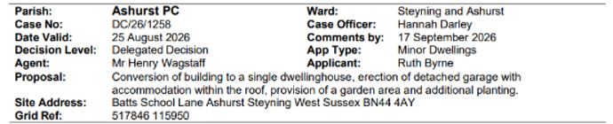
It was resolved to stay neutral but to request that, considering the proximity, sensitivity to the privacy of neighbouring properties is shown.
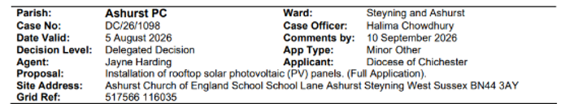
It was resolved to be neutral on the application.
- Planning Decisions from HDC
To receive and review the decisions on planning applications from Horsham District Council.
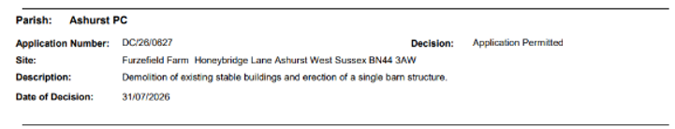
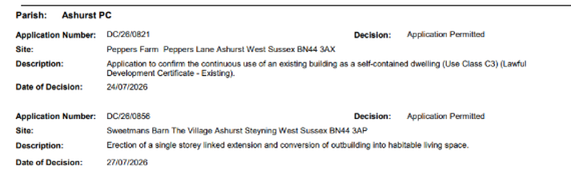
The decisions were noted
Compliance Complaints
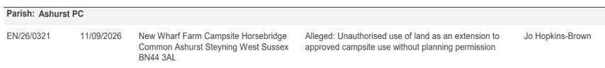
The decision was noted.
- Payments and bank reconciliation
- To review the schedule of payments and bank reconciliation since the last meeting on 16th July 2026 (see Appendix 1).
The schedule of payments made since the previous meeting held on 16th July 2026, together with the bank reconciliation, as set out in Appendix 1, was reviewed by members.
It was resolved to approve the schedule of payments since the last meeting and the bank reconciliation of 14th September 2026.
- To review the Q2 budget position.
The Clerk provided an update on the current financial position at Q2 of the budget.
It was agreed that the Clerk should now transfer the £5,250 Recreation Ground Grant, as itemised in the Budget.

It was resolved to acknowledge the update and current financial position.

- Recreation Ground
- To receive a report on the Recreation Ground Trust’s income and expenditure since
the last meeting on 16th July 2026 (see Appendix 2).
Members received and reviewed the Recreation Ground Trust income and expenditure received since the previous meeting held on 16th July 2026, as set out in Appendix 2. The financial position of the Trust was noted.

It was resolved to approve the schedule of payments since the last meeting and the bank reconciliation of 14th September 2026.

- To receive an update on the rebuild/replacement of the John Eaton Hut.
The Chair advised that the project continues to face similar challenges to those previously identified, the principal one being the lack of funds. She was pleased to advise that we now had the firm offer of help with obtaining any appropriate grants.
Re the John Eaton Hut: the Chair had received details of various pre-manufactured structures from various sources. This is currently considered the most suitable option, particularly since a rebuild is more likely to attract any (sports) grants available.

Re the Pavilion: A quotation for c£58,000 had been received for the installation of a prefabricated building on the Pavilion’s existing footings. Photographs and a quotation detailing the work involved have been received for this option.

Following a site visit, another builder had advised that there are concerns regarding the suitability of using the existing foundations for supporting a new building. One option would be to strip the structure back and rebuild only what is required, with estimated costs in the region of £30,000 to £50,000.

An alternative renovation proposal has also been discussed, involving the installation of a steel frame while retaining the existing structure where possible and replacing elements as required. This option is estimated to cost approximately £50,000.
(These proposals were in addition to an earlier quotation to renovate the Pavilion at an estimated cost of c£50,000 with possible economies of up to £5,000.)
Following discussion, members agreed that the replacement of the John Eaton Hut should be treated as a priority.

It was resolved to acknowledge the update.
- To receive a general update on the Recreation Ground.
A quotation of £1,860 has been received for the removal of the oak tree. Two further quotations are needed before a decision can be made.

Options for the management of the remaining stump were also discussed. These include leaving it in situ, as a natural feature, and exploring the possibility of adding a decorative carving as an artistic feature. Further information and costings will be obtained before any decision is taken.
As agreed, the smartening-up of the Pavilion and its surrounds, had been carried out in advance of the Dog Show. The Chair thanked the Russell Brothers for making good the brick wall outside the Pavilion, David Fischel for strimming round the side of the pavilion and trimming back the trees/hedging and Cllr Nicholson and Andrew Jesse for repainting the slide.
The Dog Show had been a successful and well attended event. Appreciation was expressed to all those who contributed to the organisation and running of this annual event, particularly those who provided support behind the scenes.

It was resolved to acknowledge the update.
d) To discuss the possible further protection of the Recreation Ground.
In light of ongoing discussions regarding local government reorganisation and the move towards a Unitary Authority, consideration is being given to options that may provide additional protection of the Recreation Ground for future generations. Members were supportive of exploring the available options in greater detail. These include registration with Fields in Trust or designation as a Town or Village Green.
It was resolved to acknowledge the update.
- Speedwatch and Speed Restrictions within the Parish
Members noted that the meeting with the West Sussex County Council Highways Officer had not taken place as planned, as the officer had failed to attend. As a result, no update was available on Speedwatch activities or potential speed restriction measures within the parish. It was agreed that the matter would be carried forward for discussion at the next meeting, once Cllr Nicholson had managed to arrange a meeting with the Highways Officer in question.

It was resolved to acknowledge the update.

- Operation Watershed
Members were advised that the Operation Watershed grant application has been approved. The project is now awaiting confirmation of a start date. It was further reported that three local farmers have agreed to accept the excavated material on their land, which will assist in facilitating the works. Members welcomed the progress.
It was resolved to acknowledge the update.
- Government email addresses and website
Following discussion, it was reported that some councillors had successfully gained access to the new council email accounts. However, a number of issues remain outstanding. It was therefore agreed that councillors would meet prior to the next Council meeting to work through the setup process together and resolve any remaining access difficulties.
It was resolved to acknowledge the update.
- Local Government Pay Settlement
Post-meeting note: For reference only - it was noted that the 3.2% increase to the Clerk’s salary would be backdated to April 2026.
- Correspondence
There was no correspondence.
- Forthcoming Dates
Next meeting to be held on November 26th 2026 at 7.30pm.

Appendix 1
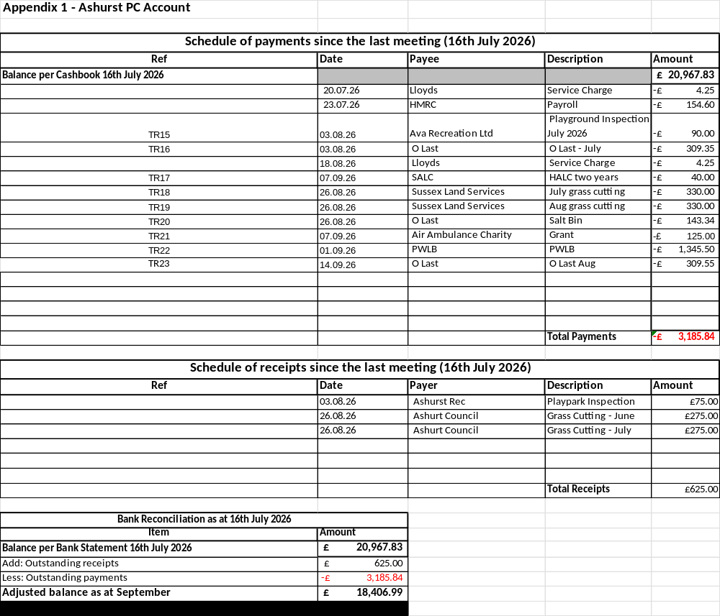

Appendix 2
